**Christenberry Elementary**

**Updated School Supply List**

**2022-2023**

**Kindergarten (please do not send supplies until students are assigned a teacher)**

Large backpack

1 inch 3 ring binder with clear view pocket in front

24 glue sticks

2 boxes of tissues

2 packs of baby wipes

2 packs of large pink erasers

Fiskars Scissors (blunt tip)

Ziploc bags (gallon or quart size, no snack size)

1 clear plastic shoebox

2 boxes of crayons (24 count)

2 boxes of washable markers

1 pack dry erase markers

Pencil Box

Reusable water bottle

Over the ear headphones

**1st Grade**

Large backpack

3 boxes of tissue

2 packs of baby wipes

1 pair Fiskar scissors

12 or more glue sticks (Elmer’s only)

Full size pencil box

4 boxes of Crayola crayons (24 count)

2 packs of 24 Ticonderoga Pencils

1 pack of yellow highlighters

1 pack of black fine tip Expo Markers

2 plastic folders WITH prongs (Black and Blue)

1 pack of Astro Bright Paper

Sandwich & gallon sized Ziploc Bags

Over the ear headphones

Reusable water bottle

**2nd Grade**

Large backpack

4 boxes of tissues

2 packs of baby wipes

2 packs of large pink erasers

1 pair of Fiskars scissors

2 pairs of headphones

6 Elmer’s glue sticks

2 packs TICONDEROGA pencils

2 packs of eraser tops

2 boxes of crayons (24 count)

Ziploc bags (girls-snack or sandwich size, boys-quart or gallon size)

Plastic pencil box

2 packs of black Expo Markers (fine tip)

2 Highlighters

Reusable water bottle

1 pack of small drinking cups (Dixie)



**3rd Grade**

Large backpack

3 boxes of tissue

1 packs of baby wipes

1 pair Fiskar scissors

1 pack of glue sticks

1 solid color folder with prongs

1 solid color folder without prongs

2 packs of black dry erase markers

40 pencils

Over the ear headphones

Boys: Gallon Sized Ziploc Bags

Girls: Sandwich Sized Ziploc Bags

**4th Grade**

Large backpack

4 folders (different colors)

4 notebooks (single subject wide ruled spiral)

Wide ruled notebook paper

Gallon size baggies

Scissors

Glue sticks

Crayons or colored pencils

Pencil box/pouch

Cap or pink erasers

Wooden #2 pencils

Black dry erase markers

Highlighter

Tissues

Reusable water bottle

Earbuds  
Disinfecting wipes

Sandwich size baggies

**Special area teachers**

Special Area teachers also need tissues, and baby wipes.

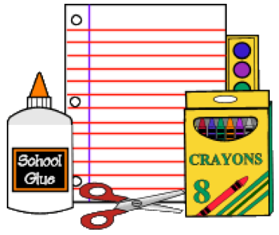

**5th Grade**

Large backpack

3 boxes of tissues

2 packs of baby wipes

1 pack of large pink erasers

1 pair of Fiskar scissors

16 glue sticks

1 set of headphones or ear buds

1 set of various colored highlighters

1 set of eight tab dividers for the binder

4 packs of pencils (Ticonderoga if possible, not mechanical)

2 packs of eraser tops

1 box of each type of Ziploc bags: sandwich, quart, and gallon size

1 pack of markers, colored pencils, crayons

6 composition lined notebook

notebooks: any color

1 multi pack of Post-it notes

4 Plastic heavy duty 3 prong pocket folder

Reusable water bottle